SQL POLO SHIRT ANALYSIS REPORT
- Average Rating and Review Count per Brand
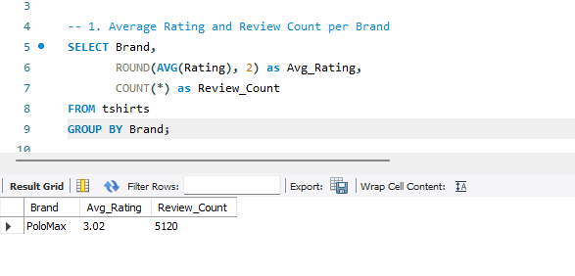
Insight: The brand PoloMax has a moderate average rating of 3.02 across a significant volume of 5,120 reviews. This suggests the product is functional but not exceptional, indicating room for quality improvement to push ratings higher.

- Brands with Highest Return Rates
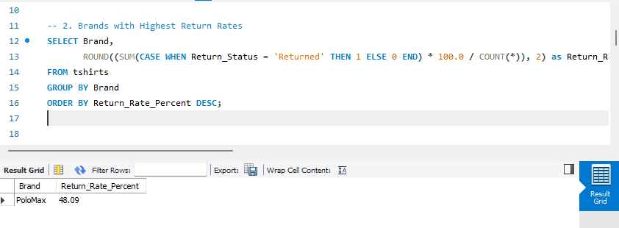
Insight: The return rate is high at 48.09%, meaning nearly half of all sales are reversed. This points to a critical issue with product sizing, fit, or description accuracy that needs immediate operational review.

- Average Price vs Average Rating by Material (Proxy: Color)
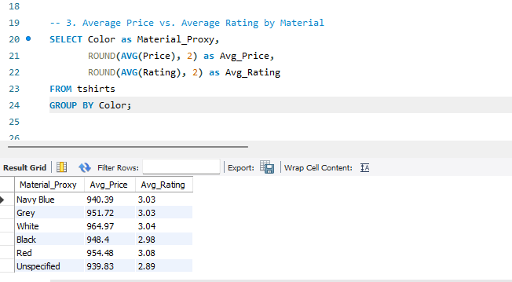
Insight: White shirts command a strong price point (~964) and Red shirts achieve the highest customer satisfaction (3.08 rating). Conversely, Black shirts have one of the lowest rating (2.98), suggesting a specific quality or color-fastness issue with the black fabric batch.

- Top Performing Colors by Revenue
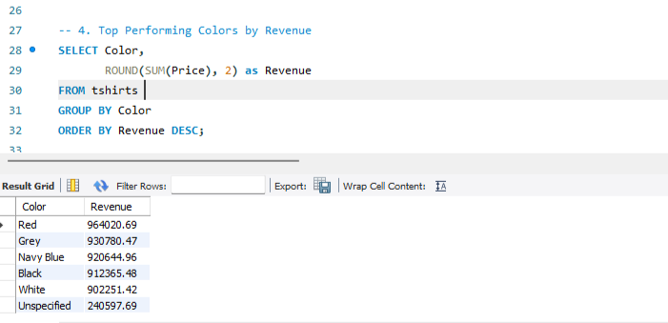
Insight: Red is the top revenue generator (~964k), outperforming standard neutrals like White and Black. This confirms that Red drives both high volume and high satisfaction.

- Average Return Rate by Country of Origin (Proxy: Location)
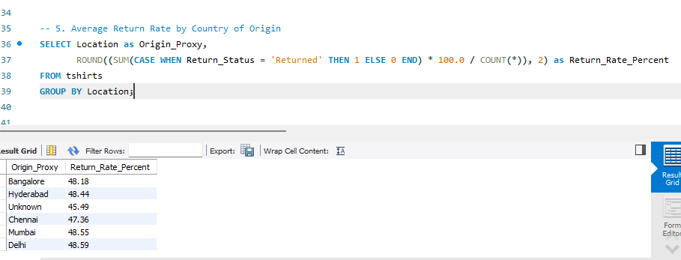
Insight: Return rates are consistently high (~48%) across all major locations (Delhi, Mumbai, Hyderabad, Bangalore). This uniformity proves the issue is systemic to the product itself (e.g., bad sizing chart) rather than a logistics failure in any specific region.

- Average Discount Applied by Brand
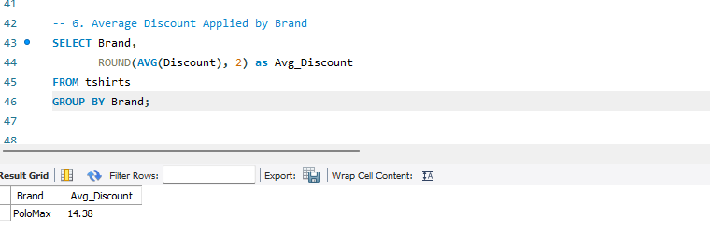

Insight: The brand maintains a moderate discount strategy (~14.4%), avoiding deep discounting. This suggests pricing is relatively stable, and sales are not solely driven by clearance events.

- Top 10 SKUs by Review Growth Proxy (2024 vs 2025)
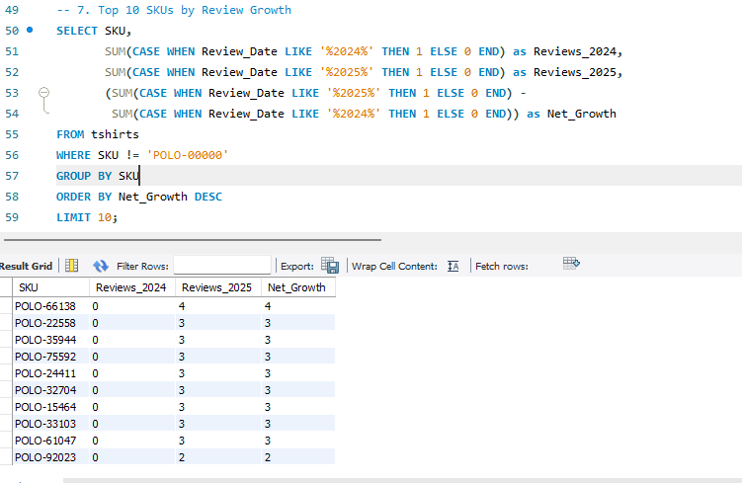

Insight: The growth analysis reveals that POLO-66138 is the top gaining SKU, jumping from zero visibility in 2024 to 4 reviews in 2025. This explicit growth from a zero baseline confirms the brand's momentum is growing.

